9. Develop an Android Calculator Application using Android Studio

Aim:
To develop an Android application that implements a basic calculator using Android controls
such as Button, TextView, and EditText. The calculator will support basic mathematical
operations like Addition, Subtraction, Multiplication, and Division.

Procedure:
  - Set up a new Android project in Android Studio.
  - Create a MainActivity Java or Kotlin file for the main screen of the
application.
  - Apply JavaScript validation for all fields.
  - EditText for input fields where the user will enter numbers (two
EditTexts for number1 and number2).
  - Buttons for each arithmetic operation (Addition, Subtraction,
Multiplication, Division).
  - Get the values entered by the user in EditText fields using getText().toString()
and convert them to numerical values (like Integer.parseInt() or Double.parseDouble()).
  - Once the result is displayed, the user can either perform another calculation or
exit the app.

Code:
- XML Layout
<?xml version="1.0" encoding="utf-8"?>
<LinearLayout xmlns:android="http://schemas.android.com/apk/res/android"
android:layout_width="match_parent"
android:layout_height="match_parent"
android:orientation="vertical"
android:background="#1E1E1E">

<TextView
android:id="@+id/result"
android:layout_width="match_parent"
android:layout_height="0dp"
android:layout_weight="1"
android:text="0"
android:textColor="#FFFFFF"
android:textSize="42sp"
android:gravity="bottom|end"
android:padding="20dp"/>

<GridLayout
android:layout_width="match_parent"
android:layout_height="wrap_content"
android:columnCount="4"
android:padding="6dp">

<Button android:id="@+id/clear" android:text="C" style="@style/btn"/>
<Button android:id="@+id/sign" android:text="+/-" style="@style/btn"/>
<Button android:id="@+id/percent" android:text="%" style="@style/btn"/>
<Button android:id="@+id/div" android:text="÷" style="@style/op"/>

<Button android:id="@+id/b7" android:text="7" style="@style/btn"/>
<Button android:id="@+id/b8" android:text="8" style="@style/btn"/>
<Button android:id="@+id/b9" android:text="9" style="@style/btn"/>
<Button android:id="@+id/mul" android:text="×" style="@style/op"/>

<Button android:id="@+id/b4" android:text="4" style="@style/btn"/>
<Button android:id="@+id/b5" android:text="5" style="@style/btn"/>
<Button android:id="@+id/b6" android:text="6" style="@style/btn"/>
<Button android:id="@+id/sub" android:text="-" style="@style/op"/>

<Button android:id="@+id/b1" android:text="1" style="@style/btn"/>
<Button android:id="@+id/b2" android:text="2" style="@style/btn"/>
<Button android:id="@+id/b3" android:text="3" style="@style/btn"/>
<Button android:id="@+id/add" android:text="+" style="@style/op"/>

<Button android:id="@+id/b0"
android:text="0"
style="@style/btn"
android:layout_columnSpan="2"/>

<Button android:id="@+id/dot" android:text="." style="@style/btn"/>
<Button android:id="@+id/equal" android:text="=" style="@style/op"/>

</GridLayout>

</LinearLayout>

Servlet (EventServletJava):
<resources>

<style name="btn">
<item name="android:layout_width">0dp</item>
<item name="android:layout_height">70dp</item>
<item name="android:layout_columnWeight">1</item>
<item name="android:textSize">20sp</item>
<item name="android:backgroundTint">#2D2D2D</item>
<item name="android:textColor">#FFFFFF</item>
</style>

<style name="op">
<item name="android:layout_width">0dp</item>
<item name="android:layout_height">70dp</item>
<item name="android:layout_columnWeight">1</item>
<item name="android:textSize">20sp</item>
<item name="android:backgroundTint">#FF9800</item>
<item name="android:textColor">#FFFFFF</item>
</style>

</resources>

Output:

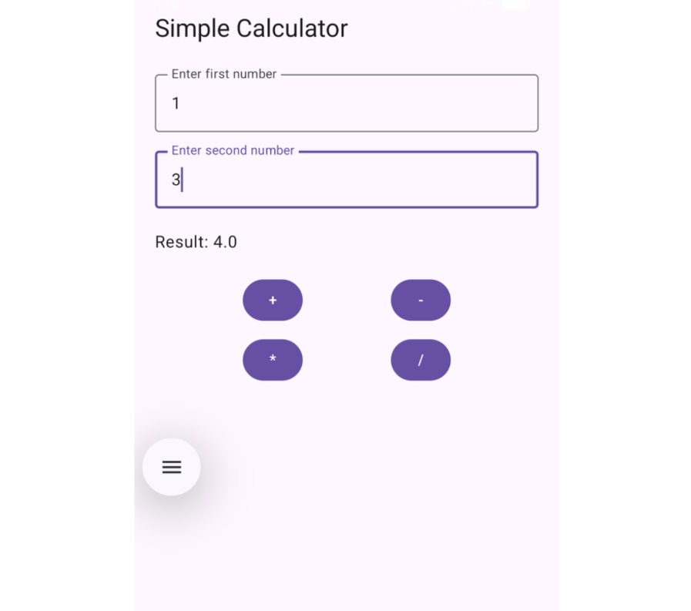

Result:
Thus, an Android application using Button, TextView, and EditText was successfully developed to perform basic arithmetic operations such as addition, subtraction, multiplication, and division.

